Assignment

- Construct a Countdown timer for a light system to count 10 seconds (9 to 0) then make green light turned on at 0.
- The design must have a button or a switch to start counting. Once the switch is pressed wait till counter comes to 0, switch off green and switch on amber.
- When Timer is at 7, switch on the red, switch off amber.
- The amber should be turned on and red light should turn off at 2.
- Timer at 0, Turn off amber and turn on green.

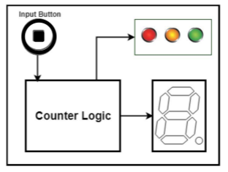

Instructions:
- You may use a 555 timer to obtain a 1Hz clock signal with 50% duty cycle.
- Decide capacitors and resistors accordingly.
- You may use 74193 counter IC in down counting mode to implement the counter.
- The counter value must be displayed in a seven-segment display digit.
- Use 7447 BCD to 7 segment decoder IC to convert binary data into 7 segment digits.
- Use Logisim to do the design and Simulation.

Marks Breakdown
